

**A Project report on**

**“GreenBee – Nursery website”**

**Submitted To**

Savitribai Phule Pune University

**Submitted By**

Arjun Jatav

Sakshi Kumari

**Under the Guidance of**

Prof. Seema Purandare

Prof. ASHWINI WAGHMARE

**Department of “Bachelor of Computer Application”**

**Ness Wadia College of commerce Pune**

**ACADEMIC YEAR 2021-2022**

**SEMISTER V**

**Introduction**

* A nursery is a place where plants are propagated and grown to a desired age.
* Mostly the plants concerned are for gardening, forestry or conservation biology, rather than agriculture.
* They include retail nurseries, which sell to the general public, wholesale nurseries, which sell only to businesses such as other nurseries and to commercial gardeners, and private nurseries, which supply the needs of institutions or private estates.
* Some will also work in plant breeding.

**Problem Definition**

Multiple factors, either of human or natural origin, cause deforestation. Natural factors include natural forest fires or parasite-caused diseases which can result in deforestation. Nevertheless, **human activities** are among the main causes of global deforestation. According to the Food and Agriculture Organization (FAO), the expansion of agriculture caused nearly **80%** of global deforestation, with the construction of infrastructures such as roads or dams, together with mining activities and urbanization, making up the remaining causes of deforestation.

* Agricultural Activities
* Livestock Ranching
* Illegal Logging
* Urbanization
* Desertification of Land
* Mining
* Forest Fires
* Paper
* Overpopulation

**Need for the New System**

* Nurseries are used for artificial plantation. We raise nurseries in those areas where natural regeneration is low or slow.
* As the increasing global warming and pollution we are creating an awareness among people about the importance of plants and trees in your surroundings.
* We aim to deliver high quality plants at the right time.

**Acknowledgement**

We are glad that we were able to complete this project and understand many things. Through preparation of this project was an immense learning experience and we inculcated many personal qualities during this process like responsibility, punctuality, confidence and others.

We would like to thank to our teachers who supported us all the time, cleared our doubts. We are taking this opportunity to acknowledge their support and we wish that they keep supporting us like this in the future.

A project is a bridge between theoretical and practical learning and with this thinking we worked on the project and made it successful due to timely support and efforts of all who helped me.

Once again, we would like to thank my Project Partner and Friends also for their encouragement and help in designing and making my project creative. We are in debt of all these. Only because of them we were able to create our project and make it good and enjoyable experience.

**Feasibility Study**

Feasibility Study in Software Engineering is a study to evaluate feasibility of proposed project or system. Feasibility study is carried out based on many purposes to analyze whether software product will be right in terms of development, implantation, contribution of project to the organization etc.

1. **Technical Feasibility**

* In Technical Feasibility current resources both hardware software along with required technology are analyzed/assessed to develop project. This technical feasibility study gives report whether there exists correct required resources and technologies which will be used for project development. Along with this, feasibility study also analyzes technical skills and capabilities of technical team, existing technology can be used or not, maintenance and up-gradation is easy or not for chosen technology etc.

1. **Operational Feasibility**

* In Operational Feasibility degree of providing service to requirements is analyzed along with how much easy product will be to operate and maintenance after deployment. Along with this other operational scopes are determining usability of product, Determining suggested solution by software development team is acceptable or not etc.

1. **Economic Feasibility**

* In Economic Feasibility study cost and benefit of the project is analyzed. Means under this feasibility study a detail analysis is carried out what will be cost of the project for development which includes all required cost for final development like hardware and software resource required, design and development cost and operational cost and so on. After that it is analyzed whether project will be beneficial in terms of finance for organization or not.

**Software & Hardware Requirement**

* Frontend: HTML, CSS
* Backend: PHP
* Language: JavaScript
* Framework: Bootstrap
* Database: MySQL
* Operating System: Windows 7 or above
* Browser: Google Chrome, Firefox, Edge
* Operating System : Windows 7 or above
* Processor : Intel i3 or above.
* RAM : 2GB or above
* Hard Disk : 256 GB or above

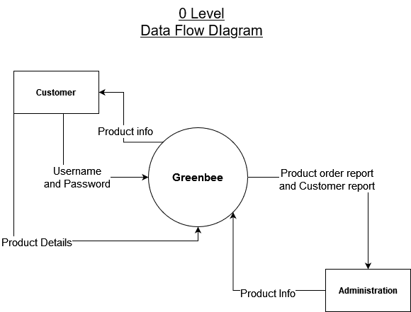

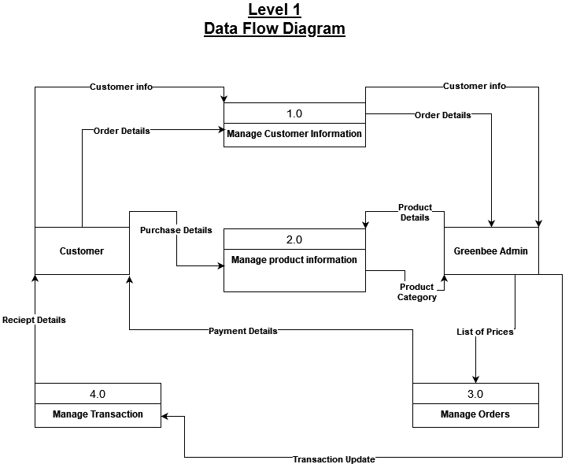

**Database Tables**

1. **Customer table**

|  |  |  |  |  |
| --- | --- | --- | --- | --- |
| **No.** | **Field name** | **Data type** | **Size** | **Constraints** |
| **1** | Cust_id | Number | 10 | Primary key |
| **2** | Username | Varchar | 20 | Not Null |
| **3** | First_name | Varchar | 20 | Not Null |
| **4** | Lastname | Varchar | 20 | Not Null |
| **5** | Email_id | Varchar | 30 | Not Null |
| **6** | Password | Varchar | 10 | Not Null |
| **7** | Mobile_no | Number | 10 | Not Null |
| **8** | Address | Varchar | 50 | Not Null |

1. **Payment table**

|  |  |  |  |  |
| --- | --- | --- | --- | --- |
| **No.** | **Field name** | **Data type** | **Size** | **Constraints** |
| **1** | Payment_id | Number | 10 | Primary key |
| **2** | Payment_type | Varchar | 20 | Not Null |
| **3** | Amount | Number | 10 | Not Null |

1. **Category table**

|  |  |  |  |  |
| --- | --- | --- | --- | --- |
| **No.** | **Field name** | **Data type** | **Size** | **Constraints** |
| **1** | Category_id | Number | 10 | Primary key |
| **2** | Category_name | Varchar | 30 | Not Null |

1. **Brands table**

|  |  |  |  |  |
| --- | --- | --- | --- | --- |
| **No.** | **Field name** | **Data type** | **Size** | **Constraints** |
| **1** | Brand_id | Number | 10 | Primary key |
| **2** | Brand_name | Varchar | 20 | Not |

1. **Products table**

|  |  |  |  |  |
| --- | --- | --- | --- | --- |
| **No.** | **Field name** | **Data type** | **Size** | **Constraints** |
| **1** | Product_id | Number | 10 | Primary key |
| **2** | Product_name | Varchar | 30 | Not Null |
| **3** | Product_model | Varchar | 20 | Not Null |
| **4** | Product_price | Number | 10 | Not Null |

1. **Cart table**

|  |  |  |  |  |
| --- | --- | --- | --- | --- |
| **No.** | **Field name** | **Data type** | **Size** | **Constraints** |
| **1** | Cart_id | Number | 10 | Primary key |
| **2** | Total_cost | Number | 10 | Not Null |

1. **Cart Item table**

|  |  |  |  |  |
| --- | --- | --- | --- | --- |
| **No.** | **Field name** | **Data type** | **Size** | **Constraints** |
| **1** | Cartitem_id | Number | 10 | Primary key |
| **2** | Quantity | Number | 5 | Not Null |
| **3** | Total_cost | Number | 10 | Not Null |

**Data Dictionary**

|  |  |  |  |  |
| --- | --- | --- | --- | --- |
| **No.** | **Field name** | **Data type** | **Size** | **Constraints** |
| **1** | Cust_id | Number | 10 | Primary key |
| **2** | Username | Varchar | 20 | Not Null |
| **3** | First_name | Varchar | 20 | Not Null |
| **4** | Lastname | Varchar | 20 | Not Null |
| **5** | Email_id | Varchar | 30 | Not Null |
| **6** | Password | Varchar | 10 | Not Null |
| **7** | Mobile_no | Number | 10 | Not Null |
| **8** | Address | Varchar | 50 | Not Null |
| **9** | Payment_id | Number | 10 | Primary key |
| **10** | Payment_type | Varchar | 20 | Not Null |
| **11** | Amount | Number | 10 | Not Null |
| **12** | Category_id | Number | 10 | Primary key |
| **13** | Category_name | Varchar | 30 | Not Null |
| **14** | Brand_id | Number | 10 | Primary key |
| **15** | Brand_name | Varchar | 20 | Not |
| **16** | Product_id | Number | 10 | Primary key |
| **17** | Product_name | Varchar | 30 | Not Null |
| **18** | Product_model | Varchar | 20 | Not Null |
| **19** | Product_price | Number | 10 | Not Null |
| **20** | Cart_id | Number | 10 | Primary key |
| **21** | Total_cost | Number | 10 | Not Null |
| **22** | Cartitem_id | Number | 10 | Primary key |
| **23** | Quantity | Number | 5 | Not Null |
| **24** | Total_cost | Number | 10 | Not Null |

**Screenshots**

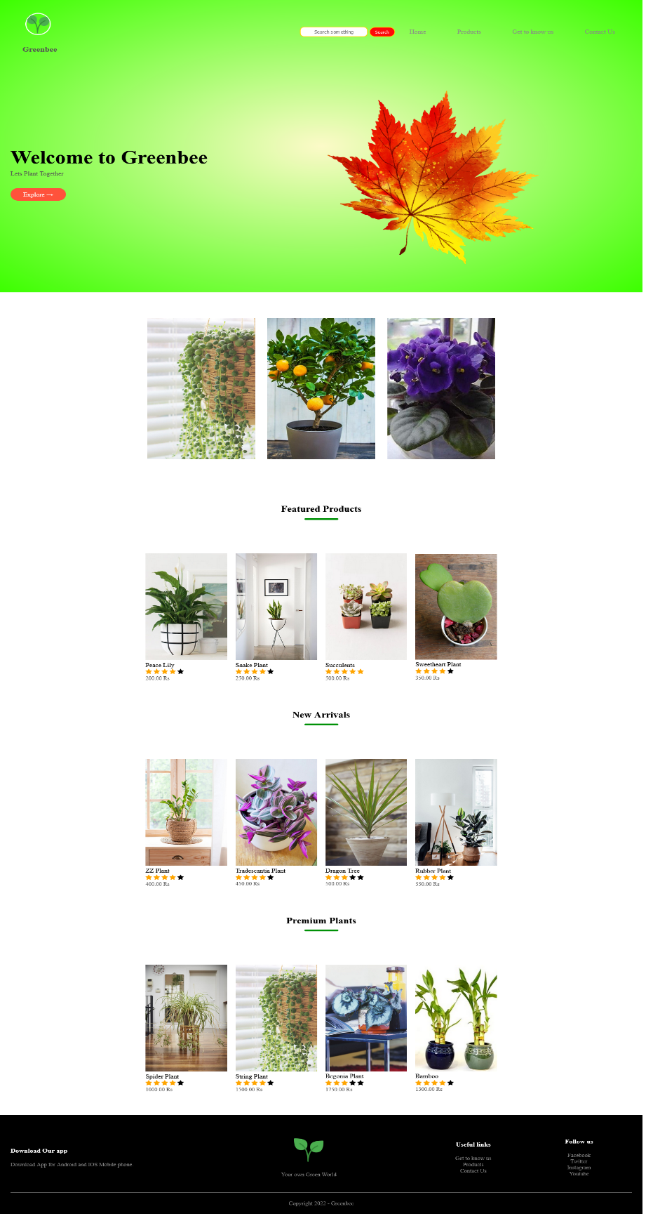

**Home Page**

**Products**

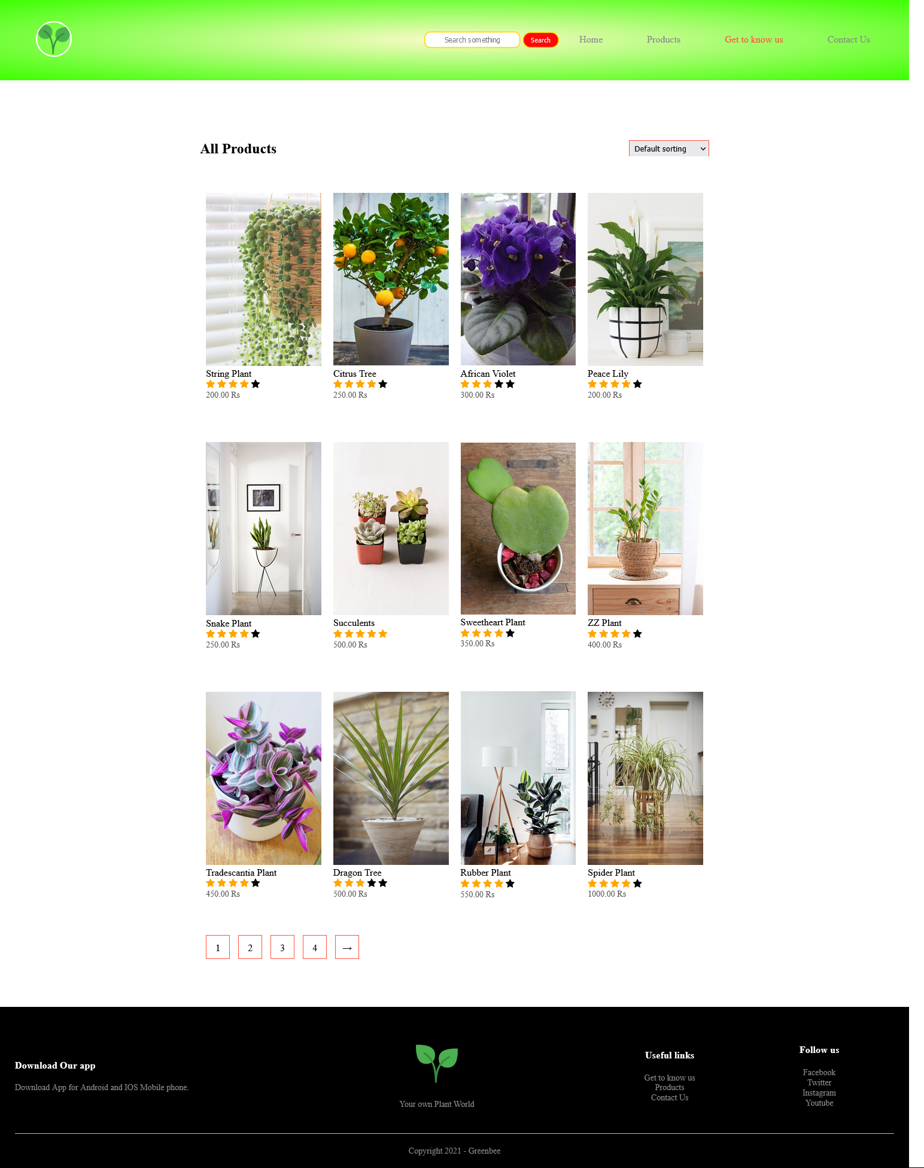

**Get to know us**

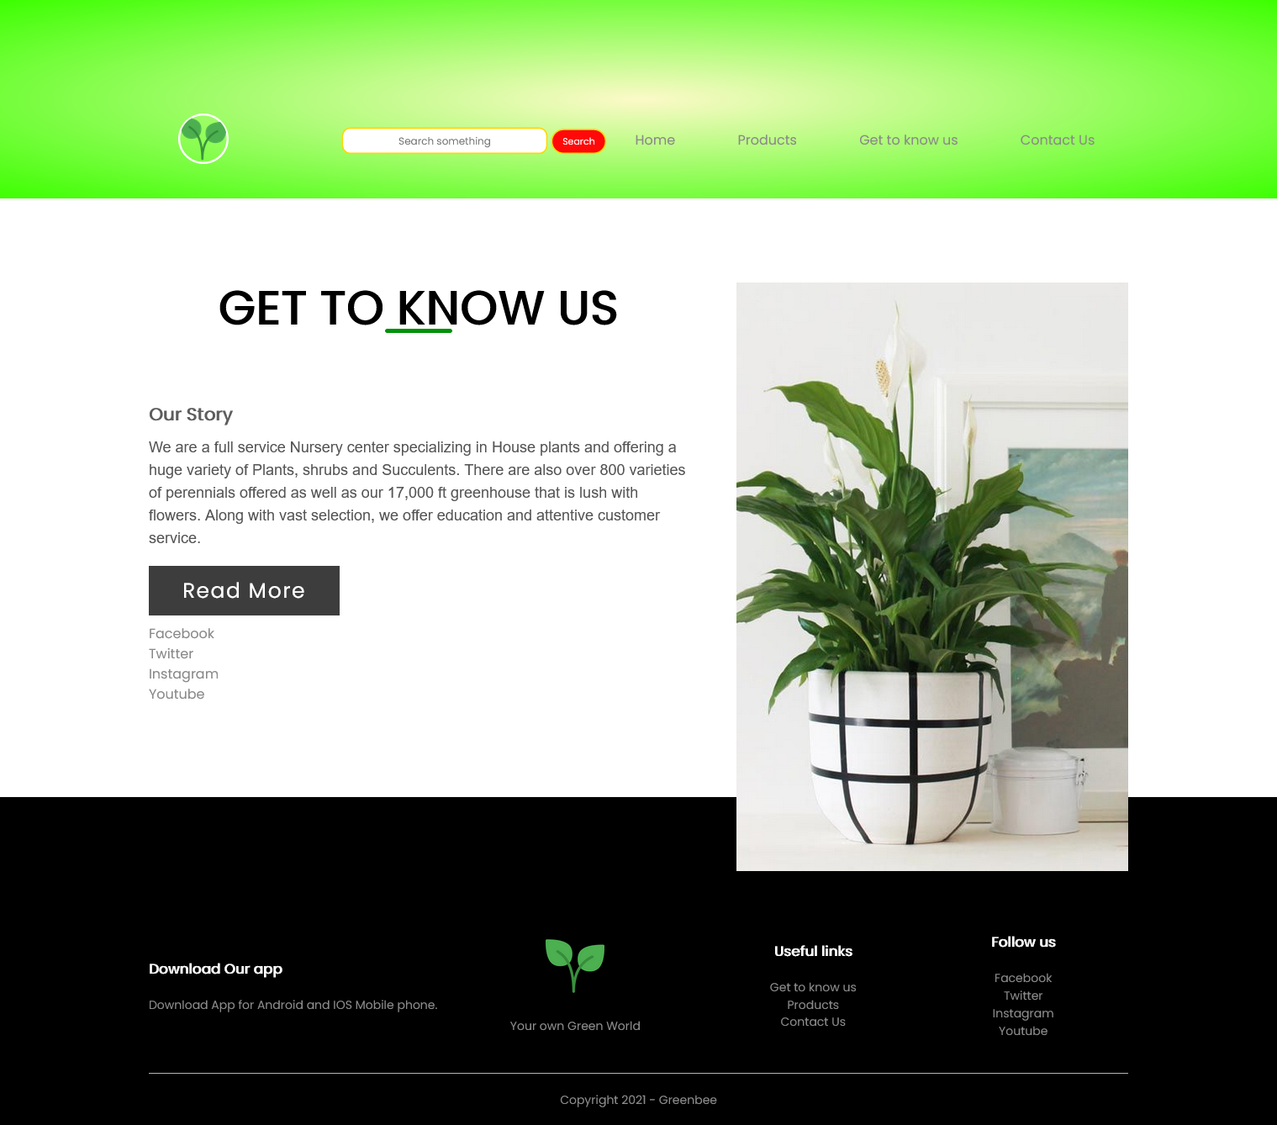

**Contact Form**

